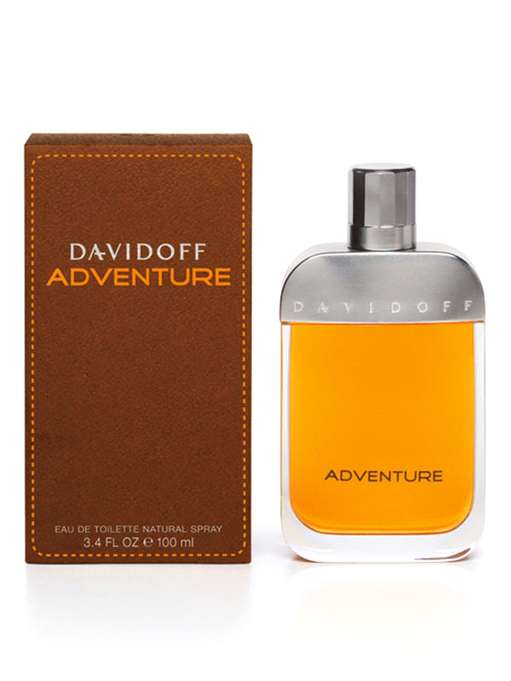

This fragrance starts with sweet and fresh notes of mandarin orange, bergamot, and sparkling lemon, followed by green tea and black pepper.

Seeds of black sesame and berries of South American pimento dominate the heart of the fragrance, and the base is made of Peruvian cedar, vetiver and light musk.

Brand Name: Davidoff

Product Code: SH-DF-9518

Quantity (ML) 100 ML

Made: Imported

Gender: Male

Price: Rs.2,999/-